Web hacking 1, Client side bypass, Tampering data, Brute-forcing
Hypertext Transfer Protocol (HTTP)
HTTP is the protocol for web communication. Currently version 1.0, 1.1 and 2.0 are in use (2.0 exists since 2015, almost all browsers support it by now).
HTTP is used in a client-server model.
The client sends a request and receives answer from the server.
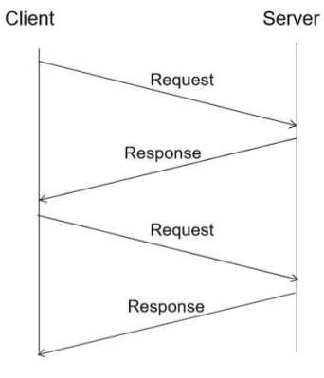

Each request and response consists of a header and a body.
The header contains all the necessary and additional information for the HTTP protocol.
Request:
- The protocol version
- The requested file
- The webmethod
- The hostname

Response:
- The web answer (in response)
- The date
- The content type

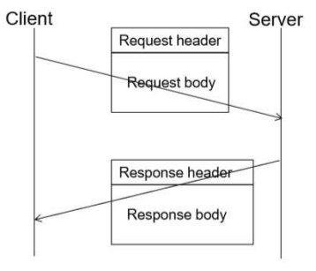

HTTP response splitting
HTTP response splitting is an old vulnerability (still appears in 2018).
In case of inappropriate validation of the requests, the client can provide misleading input (two new lines in the header indicates the end of the header).
The attacker can force the server to cache a wrong server answer.
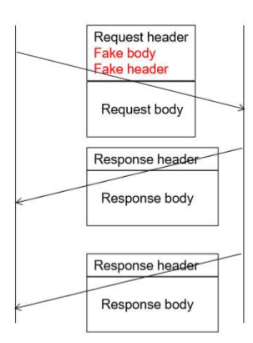

HTTP operates with several web methods. The main methods in use:
- GET – to download data
- POST – to send data (e.g I posted something on Facebook)
Other methods in use:
- HEAD – to obtain the HTTP header
- PUT – to place content on the server (e.g restful services)
Further existing methods:
DELETE (to remove content), TRACE, DEBUG, OPTIONS (to see the available webmethod list)

Hypertext Transfer Protocol – telnet
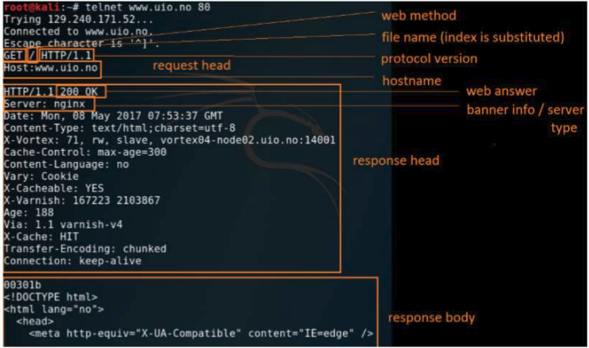

Hypertext Transfer Protocol with browser
The web communication is basically done by the web browsers.
The browsers can send optional values, such as content encoding, browser type etc
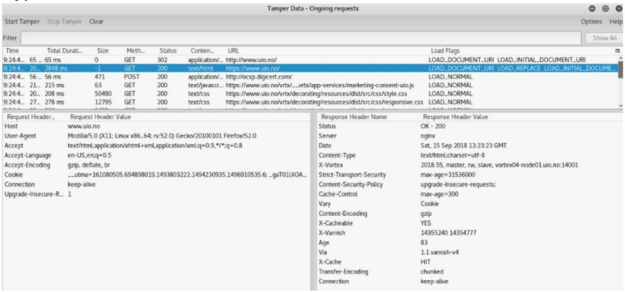
Hypertext Transfer Protocol web asnwers (HTTP status codes)
2xx: Success
- 200: OK
- 204: No content
3xx: Redirection
- 301: Moved permanently
- 302: Moved temporarily
- 304: Not modified
- 305: Use proxy
- 308: permanent redirect

4xx: Client error
- 400: Bad request
- 403: Forbidden
- 404: File not found
- 405: Method not allowed
- 408: Request timeout

5xx: Server error
- 500: Internal server error
- 502: Bad gateway
- 504: Gateway timeout
- 505: Http version not supported

HTTP PUT method – upload file
PUT method was used to place and update website content before ftp.
If it is enabled for a folder and the folder has permission to write then the attacker can take advantage of that vulnerability and upload arbitrary file.

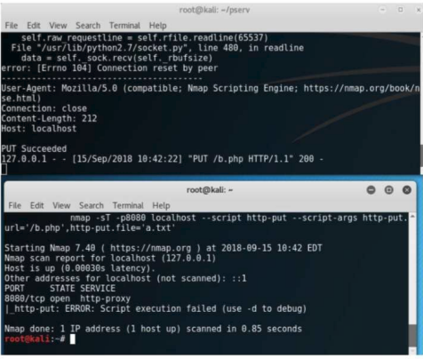

Accessing a webpage
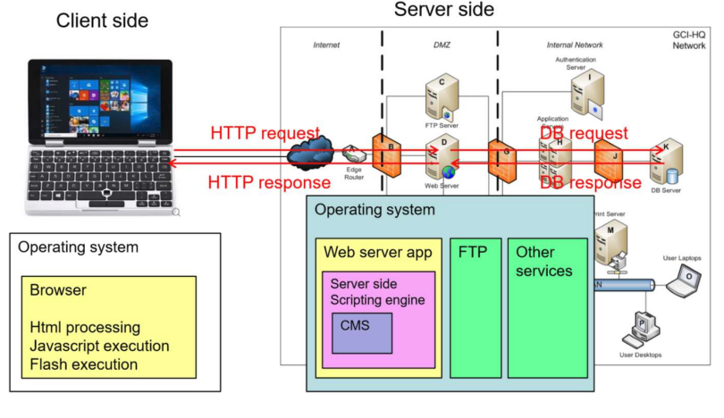
Webserver types and programming languages
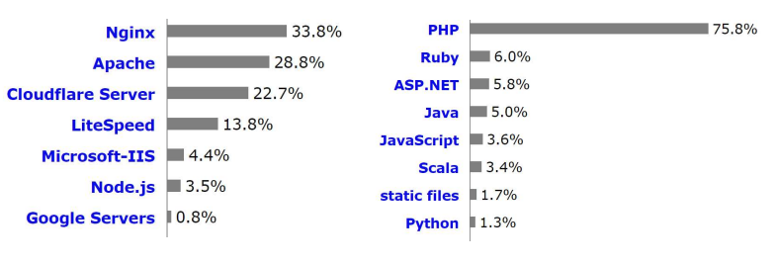
Webserver configuration
The webserver configuration file contains almost all the server settings.
The server side script settings (e.g where’s the php binary), the index file extensions (in which order should the default page be considered e.g 1.index.php, 2.index.htm), default error messages (404 File not found page) have to be placed inside the conf file
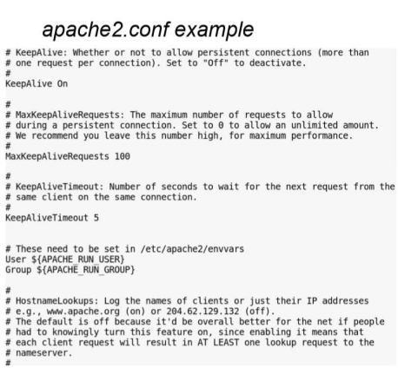

Webserver configuration (.htaccess)
An .htaccess file is a way to configure the details of your website without altering the server config files.
Main functions:
- Mod_Rewrite (is a very powerful and sophisticated module which provides a way to do URL manipulations)
- Authentication (require a password to access certain sections of the webpage)
- Custom error pages (e.g for 400 Bad request, 404 File not found, 500 Internal Server Error)
- Mime types (add extra application files, e.g special audio)
- Server Side Includes (for update common scripts of web pages)

Client side – How the browser process the html
When the browser downloads the html file it is processed
The html can contain additional files:
- Pictures (usually: png, jpg, gif)
- Stylesheets (xss)
- Javascript codes
- Flash objects (swf)
All additional content have an access address (local or global). During the processing all the additional content will be retrieved from the server with a separate web request.

The uio.no’s index.html contains several pictures, stylesheets and javascript code.
The browser downloads all step by step
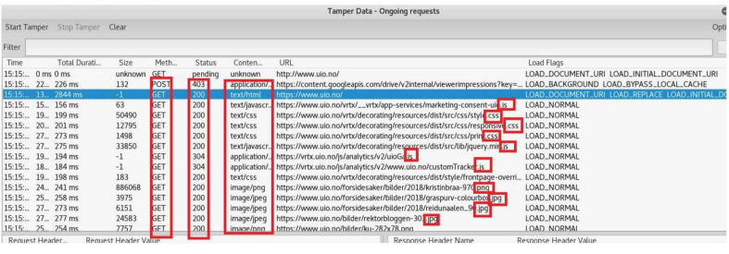
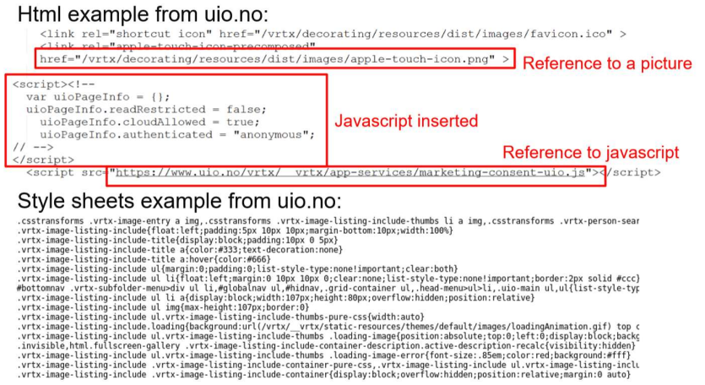
Client side code
Javascript
Alongside HTML and CSS, Javascript is one of the three core technologies of the world wide web.
Javascript enables interactive web pages and thus is an essential part of web applications. The vast majority of websites use it, and all major web browsers hav a dedicated Javascript engine to execute it,
As a multi-paradigm language, javascript supports event-driven, functional, and imperative (including object-oriented and prototype-based) programming styles.
It has an API for working with text, arrays, dates, regular expressions, and basic manipulation of the DOM, but the language itself does not include any I/O, such as networking, storage, or graphics facilities, relying for these upon the host environment in which it is embedded
Example:
<script>alert(‘Hi im the javascript engine!’);</script>

Flash
Flash is a platform for viewing multimedia contents, executing rich Internet applications, and streaming audio and video. It can be embedded to web sites.
Swf source example:
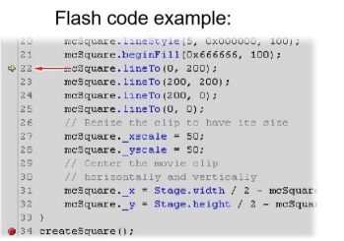
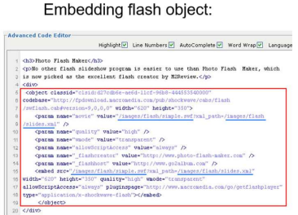

Server Side Scripts
Server side scripts are executed on the server side. Many languages exist: php, perl, ruby, java, asp, etc.
After the execution a static html is generated and that is sent to the client
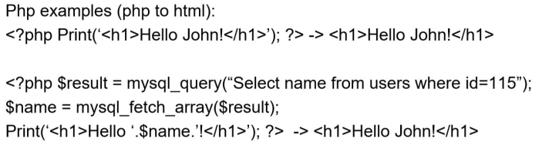

Content Management Systems (CMS)
CMS are designed to create and modify the content of Web pages easily.
The feature of CMS includes Web-based publishing, format management, history editing and version control, indexing, search, and retrieval,
Typical CMS:
- Joomla
- Drupal
- WordPress
if a vulnerability of CMS appears millions of websites can be vulnerable suddenly

Start compromising a websites
First use it in a normal way (find the linked subsites, contents, input fields)
Decide whether it is a simple static site or it has complex dynamic content (server side scripts, database behind)
Try to find not intended content (comments in source code)
Try to find hidden content without link (factory default folders, user folders configuration files)
Try to obtain as much info as it is possible (information disclosures)
Force the site to error (invalid inputs) and see the results

Prohibited content for search engines – robots.txt
Robots.txt is a file that has to be placed in the webroot folder
Search engine robots read the file and process all the disallowed entities
on the other hand it is an information disclosure
it also means that the listed entities existing
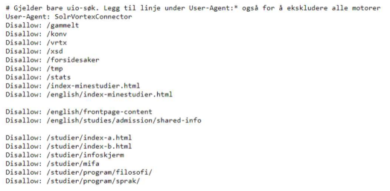
Dangerous default scripts: e.g cgi.bin/test-cgi
Cgi-bin is a protocol to execute programs through apache web server
Test-cgi is a default file.
The current directory content can be listed with it:
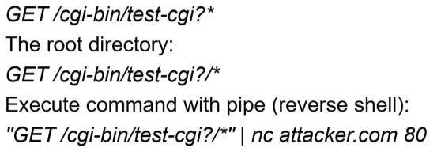

Directory burte-force / dirb
Different web servers use different default folders and default files.
Dirb has collections of typical webserver related folder names
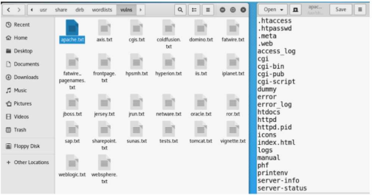

Client side filtering
Input filtering can be done on the client side. Client side input filtering is not input validation! Any data on the client side can be modified – it’s my browser, I can decide what data will be sent out.
Typical input filtering:
- Form elements with restrictions:
  - max length of input
  - restriction for special characters
  - only special characters are allowed
  - predefined input option, e.g. radiobutton, combo
- Javascript filtering:
  - the javascript is running on client side
  - more complex validation can be done
Client side filtering can be bypassed easily, that practically means no additional security.

Web developer extension
Web developer extension provides several features to modify the client side appearance.
It can:
- modify the form elements
- disable javascript
- remove validations
- etc.
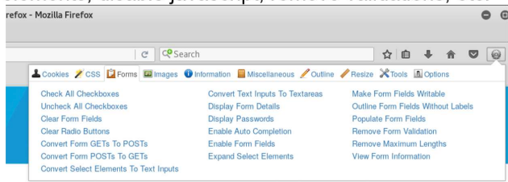

Tamper data – modifying outgoing traffic
Tamper data is also for modifying the outgoing traffic.
By clicking on the start tamper button we can intercept the traffic and modify the outgoing requests.

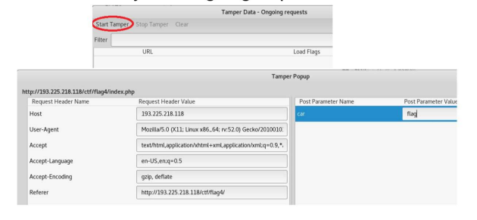

Chrome Postman
Postman interceptor can:
- set custom headers, including cookies
- view cookies already set on the domain
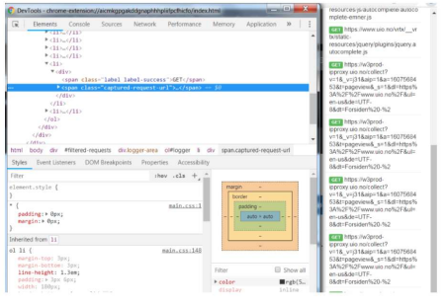

Burp Suite
Burp Suite is a tool for testing Web application security.
It provides:
- a proxy server
- several features to alter the web traffic
For example, every packet can be resent by the Repeater module and edited before at byte level.
Any client side validation can be bypassed with Burp.
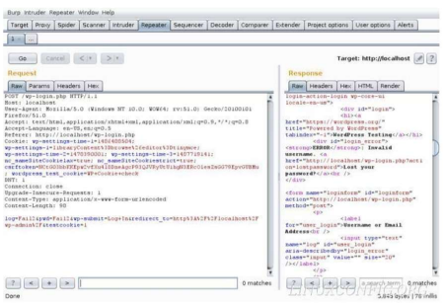

Brute force with Hydra
Hydra can be used for HTTP brute-forcing as well.
Similarly to the previously discussed protocols, the username (username file) and the password (password file) have to be provided.
Contrary to the previous cases, Hydra needs a keyword to identify negative answers (reverse brute-force).
Example:
hydra -l username -P passwordfile url.to.bf http-post-form \
"/portal/xlogin/:ed=^USER^&pw=^PASS^:F=Invalid"

